Saturday, December 8, 2018

CHAPTER 7

P.P.7.1 The circuit in Fig. (a) is equivalent to the one shown in Fig. (b).

12

+

v_{c}

+

v_{x}

+

v_{o}

8

i_{o}

1/3 F

6

(a)

1/3 F

R_{eq}

+

v

(b)

60e^{–0.25t} V

20e^{–0.25t} V

–5e^{–0.25t} A.

P.P.7.2 When t < 0, the switch is closed as shown in Fig. (a).

+

v_{c}(0)

12

4

+

24 V

6

(a)

When t > 0, the switch is open as shown in Fig. (b).

3

+

24 V

6

1/6 F

(b)

t = 0

5.333 J

P.P.7.3 This can be solved in two ways.

Method 1: Find at the inductor terminals by inserting a voltage source.

+

+

v_{o} = 1 V
+

v_{x}

i_{o}

i₁

1

2

6

2v_{x}

i₂

Applying mesh analysis gives
Loop 1: , where
(1)

Loop 2: = 8i₂ – 2i₁ – 2i₁
(2)

From (1) and (2), 5i₁ – 1i₁ = 1 or
= (1/4) A
Ω, s

Method 2: We can obtain i using mesh analysis.

+

+

v_{x}

i₁

1

2

6

2v_{x}

i₂

i

2 H

Applying KVL to the loops, we obtain
Loop 1: where
(3)

Loop 2:
(4)

Substituting (4) into (3) yields
or

Therefore,
12e^{–2t} A
and –12e^{–2t} V for all t > 0.

P.P.7.4 For t < 0, the equivalent circuit is shown in Fig. (a).

8

(b)

12

5

2 H

8

24

12

(a)

i(t)

15A

For t > 0, the current source and 24-ohm is cut off and the RL circuit is shown in Fig. (b).
,
i(t) = i(0)e^{–2t} = 5e^{–2t} A, for all t > 0.

i_{o}
P.P.7.5 For t < 0, the switch is closed. The inductor acts like a short so the equivalent circuit is shown in Fig. (a).

2

4

(a)

24 A

i

i_{o}

(b)

4

3

2

1 H

i
, ,

For t > 0, the current source is cut off so that the circuit becomes that shown in Fig. (b). The Thevenin equivalent resistance at the inductor terminals is
,
and

Thus,

P.P.7.6

A

Let .
For t < 0, .
For 0 < t < 2,
For 2 < t < 4,
For t > 4,

Thus,

or amp-sec.
which is sketched below
i dt
20
t
2
4
0

P.P.7.7

A

Remember the singularity function, r(t), is a ramp function equal to t for all values of t > 0 and equal to zero for all values of t < 0.

P.P.7.8 h(t) = –4[u(t) – u(t–2)] + (3t–8)[u(t–2) –u(t–6)]
h(t) = –4u(t) + 4u(t–2) +3tu(t–2) – 8u(t–2) – 3tu(t–6) + 8u(t–6)
h(t) = –4u(t) + (4–8+6)u(t–2) +3(t–2)u(t–2) – 3(t–6)u(t–6)
+ (–18+8)u(t–6)
h(t) = –4u(t) + 2u(t–2) + 3(t–2)u(t–2) – 3(t–6)u(t–6) – 10u(t–6)
h(t) = –4u(t) + 2u(t – 2) + 3r(t – 2) – 10u(t – 6) – 3r(t – 6).

P.P.7.9 (a)

(b)

P.P.7.10 For t < 0, the capacitor acts like an open circuit.

For t > 0, [(v(∞)–15)/2] + [(v(∞)–(–7.5))/6] = 0 or (4/6)v(∞) = 7.5–1.25 = 6.25 or

v(∞) = 9.375 V

,

= 9.375 + (15–9.375)e^{–2t}

v(t) = (9.375 + 5.625e^{–2t}) V for all t > 0

At t = 0.5, v(0.5) = (9.375 + 5.625e^{–1}) = 9.375 + 2.069 = 11.444 V

P.P.7.11 For t < 0, only the left portion of the circuit is operational at steady state.
,

For t > 0, so that the voltage source is replaced by a short circuit.

Transforming the current source leads to the circuit below.

+

v

0.2 F

10

10

30 V

+

i

,

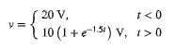

P.P.7.12 Applying source transformation, the circuit is equivalent to the one below.

1.5 H

10

60 V

+

i

5

t = 0

At t < 0, the switch is closed so that the 5 ohm resistor is short circuited.

For t > 0, the switch is open.
,

i(t) = (4 + 2e^{–10t}) A for all t > 0

P.P.7.13 For 0 < t < 2, the given circuit is equivalent to that shown below.

5 H

15

6 A

10

20

i(t)

Since switch is open at , . Also, since i cannot jump, .
,

When switch is closed, the 20 ohm resistor is short-circuited.

This will be the initial current
,
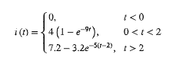
Thus,

At ,
At ,

P.P.7.14 The op amp circuit is shown below.

+

+

v_{o}

R₁

C

R_{f}

1

2
+

v

Since nodes 1 and 2 must be at the same potential, there is no potential difference across . Hence, no current flows through . Applying KCL at node 1,
which is similar to Eq. (7.4).

Hence,
,
,

Alternatively, since no current flows through , the feedback loop forms a first order RC circuit with and . Hence,

To get to from v, we notice that v is the potential difference between node 1 and the output terminal, i.e.
or

P.P.7.15 Let be the potential at the inverting terminal.
where ,

for all t
(1)

For t > 0, the switch is closed and the op amp circuit is an inverting amplifier with

From (1),

Thus, 40(1 – e^{–10t}) u(t) mV

40(e^{–10t} – 1) u(t) mV

P.P.7.16 This is a noninverting amplifier so that the output of the op amp is

To get , consider the circuit shown in Fig. (a), where is the output resistance of the op amp. For an ideal op amp, so that

(b)

R_{th}

+

C

V_{th}

R₃

R_{o}

R₂

R_{th}

(a)

The Thevenin equivalent circuit is shown in Fig. (b), which is a first order circuit.

Hence,
13.5(1 – e^{–50t})u(t) V

P.P.7.17 Answer v(t)= 8(1-e^{-t}) V, t > 0. The response is similar in shape to that in figure. 7.65.

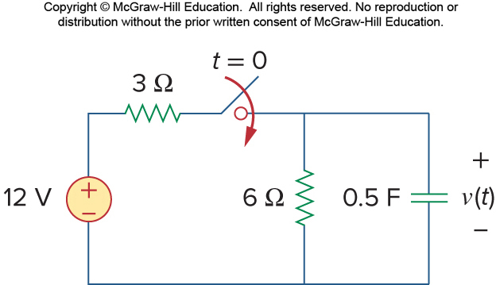

P.P.7.18 The schematic is shown in Fig. (a). While constructing the circuit, rotate L1 counterclockwise through 270 so that current i(t) enters pin 1 of L1 and set IC = 10 for L1. After saving the schematic, select Analysis/Setup/Transient to change the Final Time to 1 s. Set the Print Step slightly greater than 0 (20 ns is default). The circuit is simulated by selecting Analysis/ Simulate. After simulating the circuit, select Trace/Add in the Probe menu and display I(L1) as shown in Fig. (b).

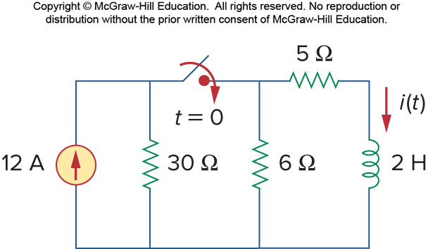

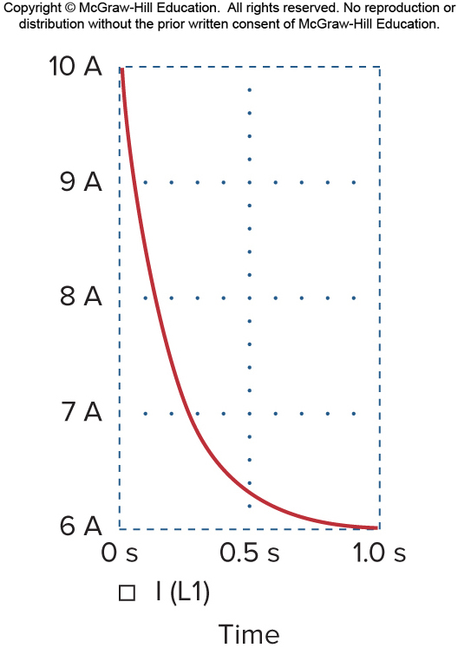

P.P.7.19 . When the switch is closed, we have the circuit shown below.

10 k

4 k

a

b

R

80 F

9 V

+

We find the Thevenin equivalent at terminals a-b.

,

Since ,

Assuming R is in k,
or

When R = 0,

When R = 6 k,

The time delay is between 47.23 ms and 124 ms.

P.P.7.20 (a) q = CV = (2x10^{–3})(80) = 160 mC.

P.P.7.21
,

P.P.7.22 (a)

